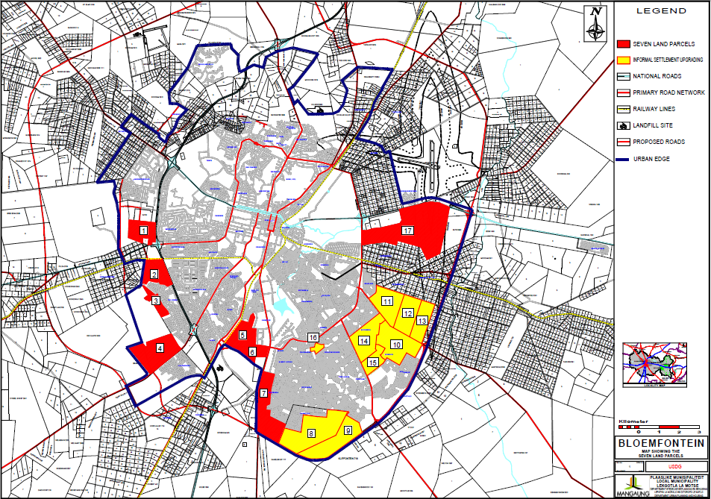

PLAN 5

LAND RELEASE FOR GAP MARKET AND BNG PROJECTS